**Module 1**

**Introduction to Communicative English:** Communicative English, Fundamentals of Communicative English, Process of Communication, Barriers to Effective Communicative English, Different styles and levels in Communicative English. Interpersonal and Intrapersonal Communication Skills.

**\*\*\*\*\*\*\*\*\*\*\*\*\*\*\*\*\*\*\*\*\*\*\*\*\*\*\*\*\***

**What is Communicative English?**

Communicative English is an approach to learning the English language that emphasizes effective communication and practical language use in real-life situations. Rather than solely focusing on grammar and vocabulary in isolation, communicative English places a strong emphasis on developing the ability to use English for various purposes, such as social interactions, business communication, academic discussions, and more.

**What are the Fundamentals of Communicative English?**

"Fundamentals of Communicative English" refers to the basic principles and skills necessary for effective communication in the English language. This typically includes aspects like grammar, vocabulary, pronunciation, listening, speaking, reading, and writing. Developing a strong foundation in these fundamentals is essential for clear and meaningful communication in both every day and professional contexts.

**What is Communication?**

Communication is a process through which two or more people exchange information, ideas, thoughts, emotions in such a way that each gain a common understanding of the intended message.

The word “Verbal Exchange” comes from the Latin word “Communis” which means “not common location” Communication is an act in which someone transmits knowledge, feelings, thoughts, and information in such a way that everyone can understand the meaning and intent.

**Types of Communication**

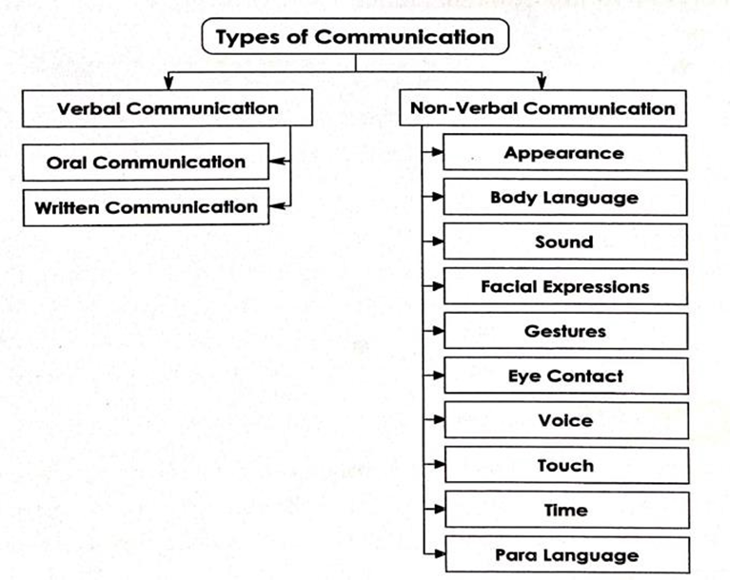

**Verbal communication**

Verbal Communication is the use of spoken or written words to convey a message, information, or ideas from one person to another.

Spoken or Written:

Verbal communication can be conveyed through spoken language or in written form. Spoken communication includes face-to-face conversations, phone calls, presentations, and speeches, while written communication encompasses texts, emails, letters, reports, and more.

**Nonverbal communication**

Non-Verbal Communication refers to the transmission of messages, information, or feelings without the use of words or verbal language. It involves conveying meaning through facial expressions, body language, gestures, postures, eye contact, tone of voice, and various other nonverbal cues. Nonverbal communication plays a significant role in human interactions and can complement, emphasize, or even contradict verbal messages.

Non-verbal communication encompasses a variety of ways through which people convey messages without using words. Here are some common forms:

**Body Language:**

* Gestures: Movements of the hands, arms, or head to express an idea or feeling.
* Posture: The way one sits or stands, which can convey confidence, openness, defensiveness, or other states.
* Facial Expressions: Movements of the facial muscles to show emotions like happiness, sadness, anger, surprise, and fear.

**Eye Contact:**

The way one looks at others, including the duration and intensity of eye contact, which can communicate interest, attention, or hostility.

**Proxemics:**

The use of personal space and the physical distance maintained between people during interactions.

**Haptics:**

Communication through touch, such as handshakes, hugs, pats on the back, or other physical contacts.

**Paralanguage:**

The non-verbal elements of speech, including tone, pitch, loudness, tempo, and pauses, which can affect the meaning of the spoken words.

**Appearance:**

The way one dresses and grooms oneself, which can convey social status, professionalism, or cultural identity.

**Artifacts:**

Personal objects and belongings used to communicate one's identity, preferences, or affiliations (e.g., jewelry, tattoos, and clothing).

**Kinesics:**

The study of body movements, including facial expressions, gestures, and posture.

**Chronemics:**

The use and perception of time in communication, such as punctuality, time spent on certain activities, and the pace of speech.

**Environmental Factors:**

The physical setting and environment where communication takes place, such as room layout, lighting, and decor, which can influence interactions and convey messages.

**Questions:**

1._______is a process through which two or more people exchange information, ideas, thoughts, emotions.

( painting, Sleeping, Communication , Running)

2.The word ________comes from the Latin word Communis.

( Photosynthesis Cryptography Verbal Exchange Aviation )

3.One example for Non- Verbal Communication

**Formal Communication and Informal Communication/ Grapevine communication**

**Formal Communication:**

Formal communication refers to the structured and systematic way in which information, messages, or ideas are conveyed within an organization, institution, or any formal setting. It follows established protocols, rules, and channels of communication to ensure that information is transmitted accurately, efficiently, and in a manner consistent with the organization's culture and hierarchy.

**Characteristics of Formal Communication**

**Structured Format:** Formal communication typically follows a predefined structure or format. It often includes elements such as a clear sender, recipient, subject, date, salutation (e.g., "Dear Sir/Madam"), and signature.

**Official Channels:** Formal communication relies on official channels or established pathways for information flow. These channels are well-documented and recognized within the organization. Examples include memos, official letters, reports, and emails sent through corporate email addresses.

**Professional Language:** Formal communication uses professional and standardized language. It avoids informal or colloquial expressions and adheres to proper grammar, punctuation, and spelling.

**Hierarchy:** In formal communication, the hierarchical structure of the organization is usually respected. Messages are often directed from higher-ranking individuals to lower-ranking ones. For example, supervisors communicate with their subordinates, and executives communicate with managers.

**Documentation:** Formal communication is often documented for reference and record-keeping purposes. It helps in creating a written trail of important decisions, policies, and agreements.

**Official Notices:** Formal communication includes the dissemination of official notices, announcements, policies, and procedures. These notices are authoritative and binding within the organization.

**Business Documents:** Many formal communication documents serve as official business records. Examples include contracts, agreements, financial reports, and meeting minutes.

**Meetings and Presentations:** Formal communication extends to meetings and presentations conducted within the organization. These events follow a structured agenda and are often led by individuals in authoritative roles.

**Legal and Compliance:** Formal communication ensures compliance with legal and regulatory requirements. It may involve legal notifications, disclosures, and adherence to industry standards.

**Impersonal Tone:** The tone of formal communication is usually impersonal and objective. It avoids emotional language and focuses on conveying information and facts.

**Approval Processes**: In formal communication, certain decisions and actions require approvals from higher authorities. This ensures that important matters are reviewed and authorized appropriately.

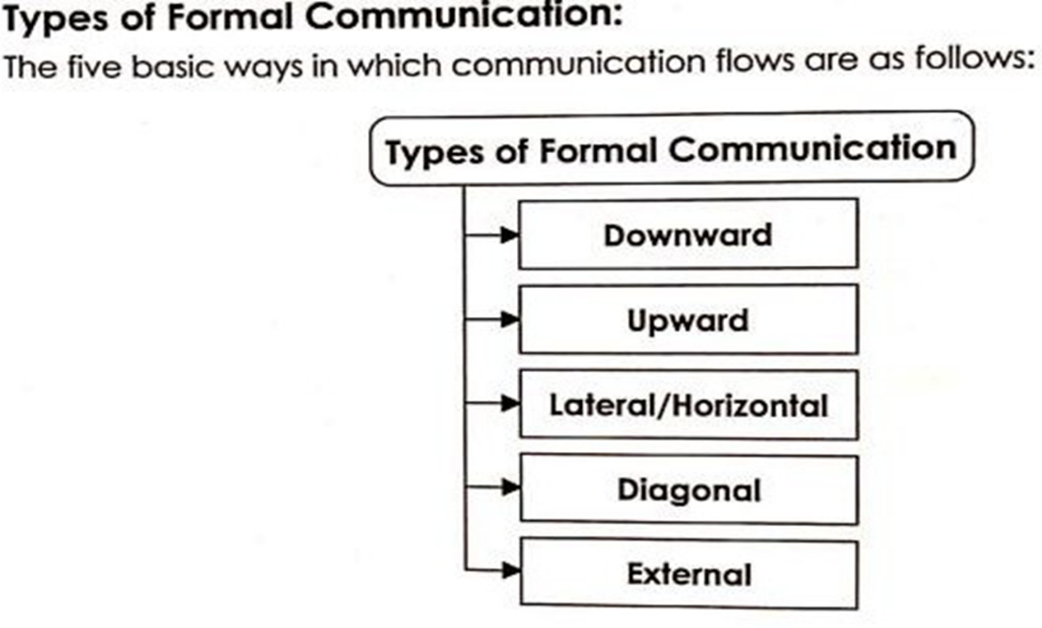

**Downward Communication:**

Downward communication refers to the flow of information from higher levels of an organization to lower levels. This type of communication is typically used by management to convey messages, instructions, policies, and feedback to subordinates.

Here are some key aspects of downward communication:

1. **Instructions and Directions:**

Managers or supervisors provide subordinates with specific instructions on how to perform tasks and achieve goals.

1. **Policies and Procedures:**

Communication of company policies, rules, regulations, and standard operating procedures.

1. **Performance Feedback:**

Providing employees with feedback on their performance, including evaluations, praise, or constructive criticism.

1. **Motivation and Encouragement:**

Encouraging employees to maintain or improve performance through motivational messages, rewards, and recognition.

1. **Announcements:**

Sharing important information such as organizational changes, new initiatives, or updates on company performance.

1. **Training and Development:**

Communicating opportunities for professional growth, training programs, and skill development.

1. **Job Assignments:**

Delegating tasks and responsibilities to employees, along with expectations and deadlines.

**Downward communication can be conveyed through various channels such as:**

* Written Memos and Emails: Official documents or electronic messages detailing specific information.
* Meetings: Formal gatherings where leaders communicate with teams or departments.
* Bulletin Boards and Newsletters: Posting important information in common areas or distributing regular updates.
* Intranet and Company Portals: Digital platforms where official communications are shared.

Effective downward communication ensures that all employees are informed, aligned with organizational goals, and aware of their roles and responsibilities. It helps in maintaining order, efficiency, and a clear understanding of expectations within the organization.

**Upwards Communication**

Upward communication is the process through which information flows from lower levels of an organization to higher levels. This type of communication allows employees to convey their thoughts, concerns, feedback, and suggestions to management. It is crucial for maintaining an open dialogue within the organization and ensuring that management is aware of issues at the ground level.

Here are some key aspects of upward communication:

1. **Feedback:**

Employees provide feedback on policies, procedures, and management practices.

1. **Reporting:**

Regular reporting of work progress, project updates, and performance metrics to supervisors or managers.

1. **Suggestions and Ideas:**

Employees share innovative ideas, suggestions for improvement, and creative solutions to problems.

1. **Concerns and Issues:**

Communicating challenges, grievances, or obstacles that employees encounter in their work environment.

1. **Employee Satisfaction:**

Providing insights into employee morale, job satisfaction, and workplace culture.

1. **Requests:**

Employees make requests for resources, support, or changes in job roles or responsibilities.

**Channels for upward communication include:**

* Surveys and Questionnaires: Tools to gather feedback from employees about various aspects of the organization.
* Suggestion Boxes: Anonymous means for employees to submit their ideas and concerns.
* Meetings and Forums: Regular meetings, such as town halls or team meetings, where employees can voice their opinions.
* Performance Reviews: Formal reviews where employees can discuss their performance and provide feedback.
* Direct Communication: Encouraging open-door policies where employees feel comfortable approaching managers directly.

Effective upward communication fosters a culture of transparency and inclusion, leading to improved decision-making, increased employee engagement, and a better understanding of the workforce's needs and perspectives. It helps management to identify and address issues proactively and harness the collective knowledge and creativity of the organization.

**Horizontal or Lateral Communication:**

Horizontal or lateral communication refers to the exchange of information between individuals, teams, or departments at the same hierarchical level within an organization. This type of communication is essential for coordinating activities, solving problems, sharing information, and building relationships across the organization.

Here are some key aspects of horizontal communication:

1. **Coordination:** Ensures that different departments or teams are working together efficiently to achieve organizational goals.
2. **Problem-Solving:** Facilitates the sharing of ideas and solutions between peers to address common challenges or issues.
3. **Information Sharing:** Enables the dissemination of important information, updates, and knowledge across departments.
4. **Collaboration:** Promotes teamwork and collaboration on projects that require input or expertise from multiple areas of the organization.
5. **Conflict Resolution:** Helps in resolving conflicts or misunderstandings between departments or teams by encouraging open dialogue.
6. **Innovation:** Fosters a culture of innovation by allowing employees to share creative ideas and perspectives with their peers.

**Channels for horizontal communication include:**

* **Meetings:** Regular cross-departmental or team meetings to discuss projects, progress, and plans.
* **Emails and Memos:** Written communications that are circulated among peers to share information or updates.
* **Instant Messaging and Collaboration Tools:** Platforms like Slack, Microsoft Teams, or other internal communication tools that facilitate real-time communication and collaboration.
* **Informal Interactions:** Casual conversations and informal interactions that occur naturally in the workplace.
* **Joint Task Forces or Committees:** Groups formed to address specific issues or projects that require input from multiple departments.

Effective horizontal communication can lead to better coordination, more innovative solutions, and a more cohesive organizational culture. It ensures that everyone is on the same page, reduces duplication of efforts, and leverages the collective expertise of the organization.

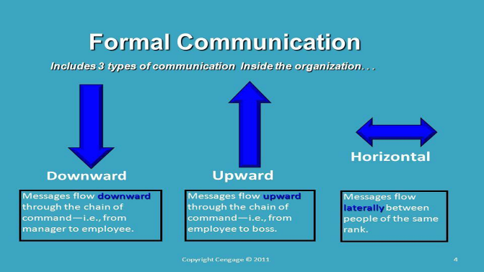

**Diagonal or crosswise communication**

Diagonal or crosswise communication refers to the exchange of information across different levels and departments within an organization, cutting through traditional hierarchical and functional lines. This type of communication can occur between managers and employees at different levels who are not directly connected in the organization's hierarchy.

Here are some key aspects of diagonal communication:

1. **Cross-Departmental Interaction:** Facilitates communication between different departments that may not typically interact, promoting a more integrated approach to problem-solving and project management.
2. **Efficiency and Speed:** Allows for quicker decision-making and problem resolution by bypassing the traditional chain of command, reducing delays associated with hierarchical communication.
3. **Innovation and Collaboration:** Encourages innovative thinking by bringing together diverse perspectives from different areas of the organization.
4. **Reducing Silos:** Helps break down organizational silos, fostering a culture of openness and collaboration.
5. **Employee Engagement:** Increases employee engagement by involving individuals from different levels and departments in decision-making processes.

Channels for diagonal communication include:

* **Cross-Functional Teams:** Groups formed with members from different departments and levels working together on specific projects or initiatives.
* **Task Forces and Committees:** Special committees that include members from various levels and departments to address particular issues or goals.
* **Workshops and Training Programs:** Opportunities for employees from different areas to interact, learn from each other, and collaborate.
* **Internal Communication Platforms:** Tools like intranets, collaboration software, and social media platforms that facilitate direct communication across the organization.

Effective diagonal communication can lead to better coordination, a more dynamic flow of information, and a more adaptable organizational structure. It leverages the strengths and insights of a diverse workforce, leading to more effective problem-solving and innovation.



**External Communication:**

External communication refers to the exchange of information between an organization and individuals or entities outside of it. This type of communication is crucial for building and maintaining relationships with customers, clients, suppliers, investors, regulators, and the general public. Effective external communication helps an organization to build its brand, manage its reputation, and achieve its business objectives.

Here are the key forms and channels of external communication:

**Marketing and Advertising:**

* Advertisements: Print, TV, radio, online ads.
* Social Media Marketing: Engaging with audiences on platforms like Facebook, Twitter, Instagram, LinkedIn.
* Content Marketing: Blogs, videos, infographics, podcasts.

**Public Relations:**

* Press Releases: Official statements issued to media outlets to announce significant events, product launches, or other news.
* Media Relations: Building and maintaining relationships with journalists and media organizations.
* Events: Hosting or participating in conferences, trade shows, and other events.

**Customer Communication:**

* Customer Support: Email, phone, chat support, and helpdesk services.
* Newsletters: Regular updates sent to customers via email.
* Surveys and Feedback Forms: Gathering customer opinions and feedback.

**Corporate Communication:**

* Annual Reports: Detailed reports on the company’s activities, financial performance, and strategic direction.
* Investor Relations: Communication with shareholders, investors, and financial analysts through meetings, reports, and presentations.
* Regulatory Communication: Interaction with government agencies and compliance with legal requirements.

**Sales Communication:**

* Proposals and Quotations: Documents sent to potential clients outlining the services or products offered.
* Sales Calls and Meetings: Direct interaction with prospects and clients to discuss business opportunities.

**Partnership and Collaboration:**

* Joint Ventures: Communication related to partnerships and collaborations with other businesses.
* Supplier Communication: Interaction with suppliers for procurement and supply chain management.

**Crisis Communication:**

* Crisis Management Plans: Pre-prepared strategies for communicating during crises.
* Emergency Notifications: Rapid dissemination of information during emergencies.

**Digital Communication:**

* Website Content: Information provided on the company’s website, including blogs, FAQs, and resource centers.
* Webinars and Online Seminars: Interactive sessions held online to engage with external audiences.

**Goals of External Communication:**

* **Brand Building:** Establishing and enhancing the company’s image and reputation.
* **Customer Engagement:** Creating and nurturing relationships with customers.
* **Reputation Management:** Managing public perception and mitigating negative publicity.
* **Information Dissemination:** Sharing important information with external stakeholders.
* **Sales and Marketing:** Promoting products or services to drive sales and revenue.
* **Stakeholder Engagement:** Building trust and rapport with investors, regulators, and the community.

**Key Considerations for Effective External Communication:**

* Clarity and Consistency: Ensuring that messages are clear, consistent, and aligned with the organization’s values and objectives.
* Audience Understanding: Tailoring messages to the needs and preferences of different external audiences.
* Responsiveness: Being responsive to external inquiries and feedback.
* Transparency: Being open and honest in communication to build trust.

Effective external communication helps an organization to connect with its external stakeholders, build its brand, and achieve its business goals. It requires careful planning, execution, and continuous monitoring to ensure that the organization’s messages are effectively reaching and resonating with the target audiences.

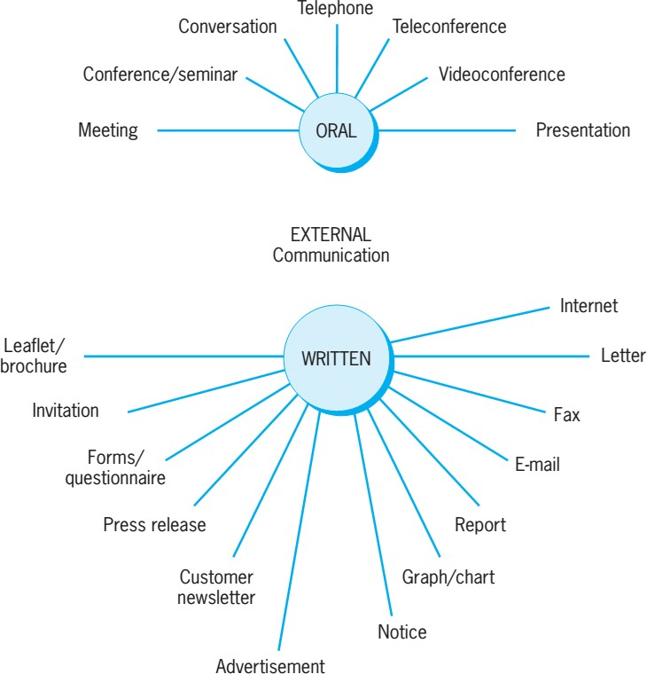

**Informal Communication/ Grapevine Communication**

Grapevine communication refers to the informal, unofficial, and often rumor-based method of information exchange within an organization. It is characterized by the spread of information or rumours among employees through informal channels, such as conversations, gossip, or social interactions, rather than through formal communication channels like official memos or meetings. Grapevine communication can be both positive and negative, and it often operates outside the control of management. It is essential for organizations to manage grapevine communication to ensure that accurate information is disseminated and to prevent the spread of misinformation or rumours.

Questions:

1.Two Types of communications:

( formal /informal , Horizontal/Vertical, Visual/Auditory, Public/Private )

2.Giving feedback on workers performance is

( Lateral Communication, Upward Communication, Internal Communication, Downward Communication)

3.One example for external communication :

( Brochure, Essay, Email )

**Process of Communication**

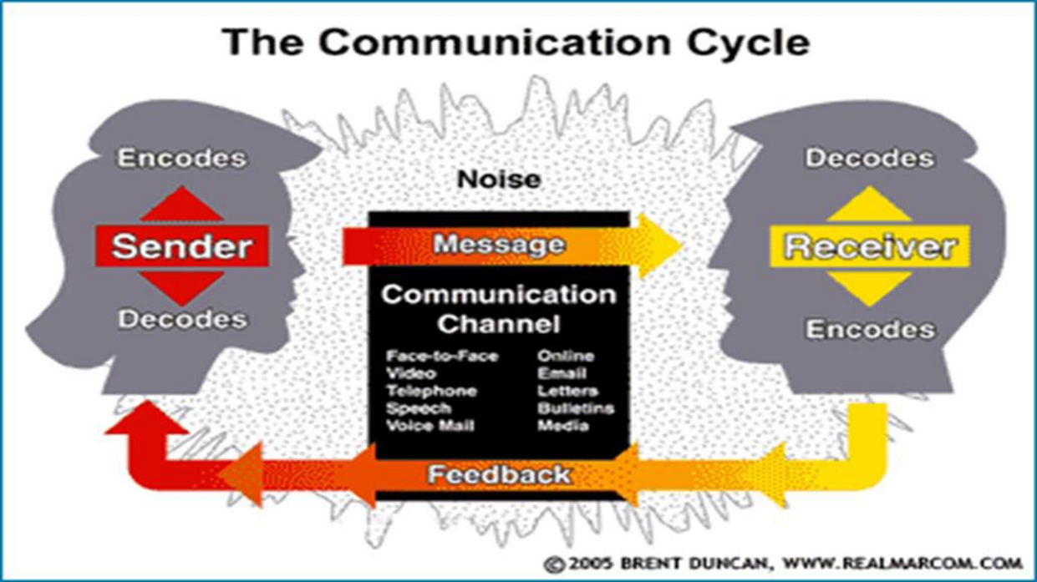

**Channel:** The message is transmitted through a communication channel or medium. Common channels include face-to-face conversations, written documents, phone calls, emails, video conferences, and more.

**Decoding:** The receiver, or the person on the receiving end, decodes the message. Decoding is the process of interpreting and making sense of the message by understanding its content and context.

**Receiver:** The receiver is the intended recipient of the message. They receive, interpret, and respond to the message.

**Feedback:** Communication often involves a feedback loop where the receiver responds to the message. Feedback can be verbal or non-verbal and provides the sender with information about how well the message was understood.

**Noise:** Noise refers to any interference or factors that can disrupt the communication process. It can include physical distractions, language barriers, technical issues, or even misunderstandings.

**Barriers of Communication**

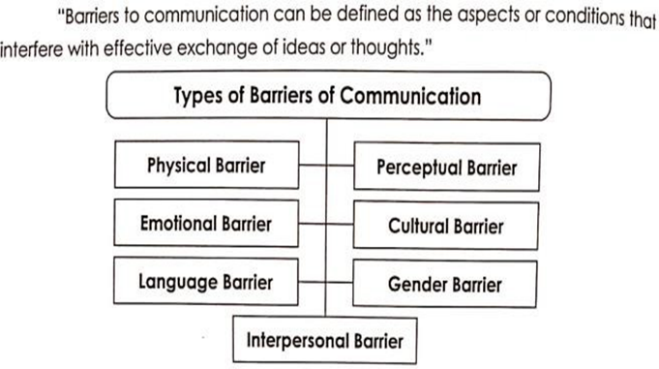

1. **Language Barriers:** Differences in language, dialects, or terminology can hinder effective communication, especially in multicultural or international settings.
2. **Noise:** Environmental noise, such as loud machinery, background conversations, or poor audio quality, can disrupt communication and make it difficult to hear or understand messages.
3. **Physical Barriers:** Physical obstacles like distance, closed doors, or other structural elements can prevent face-to-face communication and limit visual cues.
4. **Emotional Barriers:** Emotional states, such as anger, stress, anxiety, or emotional trauma, can impact an individual's ability to communicate clearly and rationally.
5. **Cultural Differences:** Diverse cultural norms, customs, values, and communication styles can lead to misunderstandings if not considered and respected.
6. **Stereotypes and Prejudices:** Preconceived notions, stereotypes, or biases about others can lead to unfair judgments and hinder open and unbiased communication.
7. **Lack of Clarity:** Unclear or ambiguous messages, vague instructions, or poor articulation can confuse the receiver and hinder effective understanding.
8. **Non-Verbal Communication:** Inconsistent or conflicting non-verbal cues, such as body language, facial expressions, or gestures, can lead to mixed messages.
9. **Information Overload:** Receiving too much information at once can overwhelm individuals and make it challenging to focus on important messages.
10. **Selective Listening:** When individuals only pay attention to parts of a message that confirm their existing beliefs or opinions, they may miss critical information.
11. **Filtering:** In some cases, people may intentionally withhold or alter information before passing it on, leading to a loss of accuracy in communication.
12. **Technology Issues:** Technical glitches, poor internet connections, or misunderstandings related to digital communication tools can disrupt virtual communication.
13. **Physical Barriers:** Disabilities or physical limitations may affect a person's ability to communicate effectively. Accessible communication methods are essential in such cases.
14. **Time Constraints:** Rushed or time-sensitive communication may lead to incomplete or inaccurate messages.
15. **Organizational Hierarchy:** Hierarchical structures within organizations can deter open communication, as individuals may hesitate to share feedback or concerns with higher-ranking colleagues.
16. **Lack of Feedback:** Failing to provide or seek feedback can result in one-way communication and a lack of confirmation that the message was understood.

**Different styles and levels in Communicative English.**

The "7 C's of Communication" is a helpful mnemonic device that represents seven key principles for effective communication. These principles can be applied in various forms of communication, such as written, verbal, or visual. Here are the 7 C's of communication:

**Clarity:** Your message should be clear and easy to understand. Avoid jargon, complex language, or ambiguous statements. Use simple and straightforward language that your audience can comprehend without confusion.

**Conciseness:** Keep your communication concise and to the point. Avoid unnecessary elaboration or wordiness. Express your message in a succinct manner, emphasizing important details and omitting irrelevant information.

**Coherence:** Ensure that your message is logically organized and flows smoothly. Present your ideas in a coherent and structured manner so that your audience can follow the progression of your thoughts.

**Correctness:** Maintain accuracy in your communication. Check for correct grammar, spelling, and punctuation. Inaccurate information can lead to misunderstanding and loss of credibility.

**Completeness:** Provide all the necessary information required for your message to be effective. Avoid leaving gaps or omitting crucial details that your audience needs to know. Make sure your message answers the who, what, when, where, why, and how questions, as applicable.

**Consideration:** Take into account the needs, perspectives, and feelings of your audience. Tailor your message to resonate with your audience's interests and concerns. Show empathy and respect in your communication.

**Courtesy:** Maintain a polite and respectful tone in your communication. Use courteous language and considerate behaviour. Show appreciation for your audience's time and attention. Avoid offensive or disrespectful language.

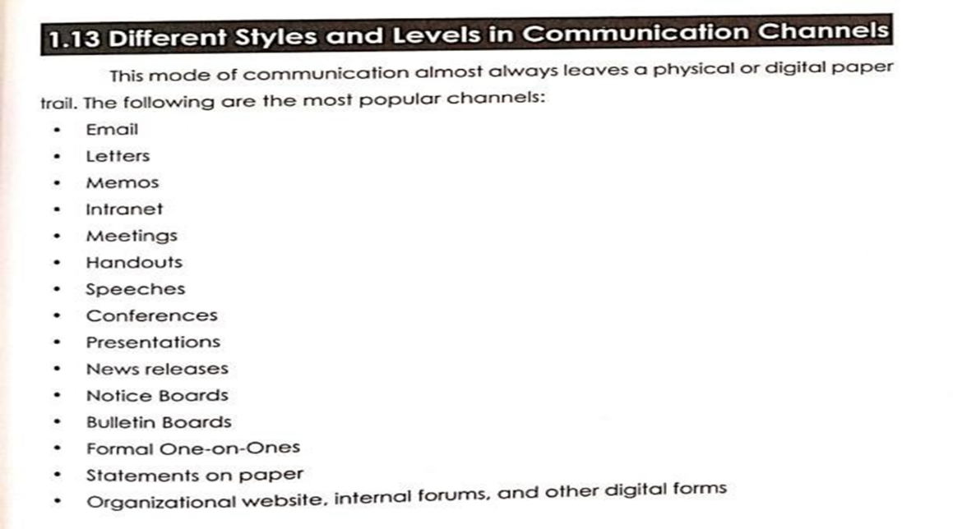

**Interpersonal and Intrapersonal Communication Skills.**

**Interpersonal Communication**

Interpersonal communication skills refer to the ability to interact and communicate effectively with others in various social and professional settings. These skills are essential for building and maintaining relationships, resolving conflicts, and conveying messages clearly and persuasively.

**Intrapersonal Communication**

Intrapersonal communication skills refer to the ability to communicate effectively with oneself. This internal dialogue involves thoughts, self- reflection, and self-awareness. While it may not involve direct interaction with others, intrapersonal communication is crucial for personal growth, decision-making, and emotional regulation.

**Questions:**

1.Intrapersonal communication skills refer to the ability to communicate effectively with____

( oneself, others, none, multiple persons)

2.Interpersonal communication skills refer to the ability to interact and communicate effectively with ________

( others, to one self, can’t say)

3.Preconceived notions, stereotypes, are example_________ kind of barrier.

( Physical, Psychological, organizational)

***************